Heart Disease Analysis

MENTOR NAME: SRI LANKA LAKSHMINARAYANA SIR
FACULTY MENTOR NAME: K. RATNA KUMARI MADAM
TEAM ID: LTVIP2026TMIDS58782
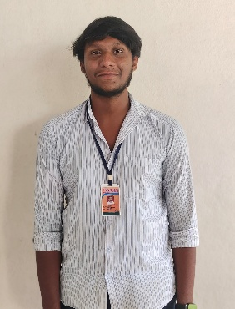
TEAM LEADER
NAME : GANTA NAVEEN
ID : SBAP0052563
Email : naveen232214@gmail.com
TEAM MEMBER
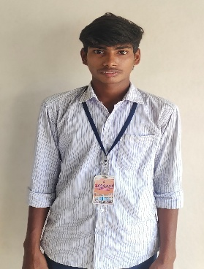
NAME : BADAM SRI RAMA SAI NARASIMHAMURTHY
ID: SBAP0052639
EMAIL: badamnarsimha405@gmail.com

TEAM MEMBER
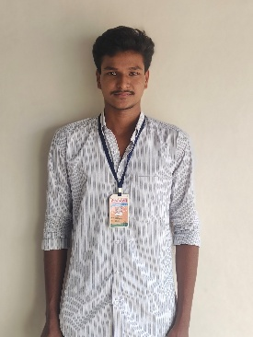
NAME : RONGALA NITEESH
ID : SBAP0052592
EMAIL: rongalaniteesh000@gmail.com

TEAM MEMBER
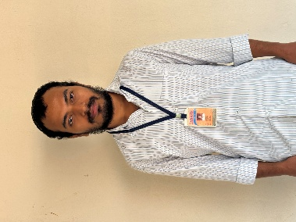
NAME : SHAIK ABDULLA
ID : SBAP0052616
EMAIL: sk0003118@gmail.com

TEAM MEMBER
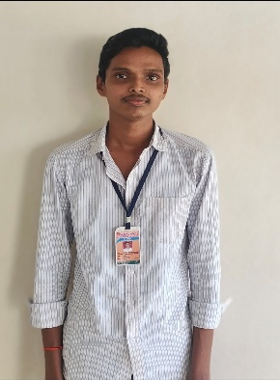
NAME : KADIYALA LOHITH SESHA VEERA SURYA VAMSI
ID : SBAP0052620
EMAIL: lohithk2211@gmail.com

TEAM MEMBER
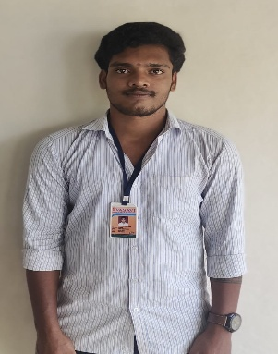
NAME : BANDIREDDY MAHESH DURGA RAJU
ID: SBAP0052626
EMAIL: maheshdurgaraju@gmail.com

